**CSC 5750 – Principles of Web Technology**

**Homework 4 – Raisa Zaman**

**25 points – Due March 25, 5pm**

**Late deadline is March 27, 11:59pm, but 20% off**

**a)** Save this document with your name and the homework number somewhere in the file name.

**b)** Paste your code and screenshots into the document.

**c)** Gather the following files into a ZIP file with your name and the homework number somewhere in the file name:

● This document

● All HTML files

● All CSS files

● Image files

● Any other optional files specific to your implementation

**d)** Submit the ZIP file to Canvas where you downloaded this document.

You've been hired again by the arena to enhance the web site you created for them in Homeworks 1-3. Start with the web site you created in Homework 3, or the Homework 3 key on Canvas, and make the following changes to it. All files referenced here should exist in both a development and a production folder. The production folder was created in Homework 3, part 1 of 2.

**Arena page**

● Update the header comment.

● Add text ", v4" to the end of the title (in the <head> section).

No other changes are needed.

**Events page**

● Add text ", v4" to the end of the title (in the <head> section).

No other changes are needed.

**Tickets page**

● Add text ", v4" to the end of the title (in the <head> section).

● You may have used a combo box to select the seat type. This will be replaced by a set of radio buttons. Add JavaScript function **setSeats** to loop through the seats array, extract the seat types, and use them to build the radio buttons. Use DOM functions createElement, setAttribute, createTextNode, and appendChild to create and attach the radio buttons to an enclosing tag (<div> works). Use an HTML set of radio buttons as a guide. Insure that the first radio button is selected by default. For example:

inp.setAttribute("checked", true);

Also, note that the text for a radio button and breaks (<br>) between radio buttons are children of the radio button but of the enclosing tag. Write a message to the console that reports that the radio buttons were set.

● Modify function **seatTypeSelected** so that the seat type selection comes from the radio buttons, not another control.

● Modify the form action to go to the **Tickets Confirmation page** (described below) instead of **Tipjar**.

● Since there are data dependencies among the functions, use the following call sequence to insure that the next function doesn't begin until the previous function has completed:

loadSeats → loadEvents → setSeats → setEvents → seatTypeSelected

**Tickets Confirmation page**

● Create a **Tickets Confirmation page** that uses PHP to retrieve and display data sent from the Tickets page. Here is a sample page:

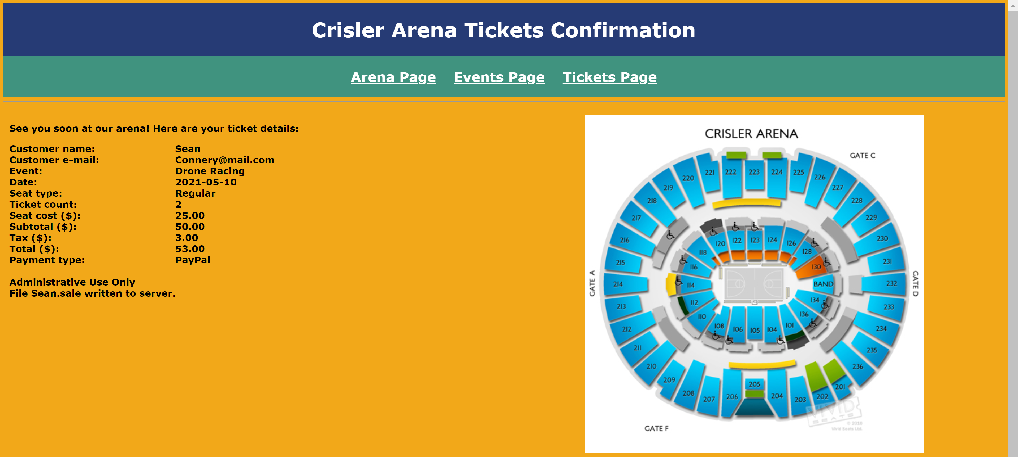

Also write file **<customer-name>.sale** that includes the tickets confirmation information, one datum per line. Write the file name to the page as shown. Here is a sample file:

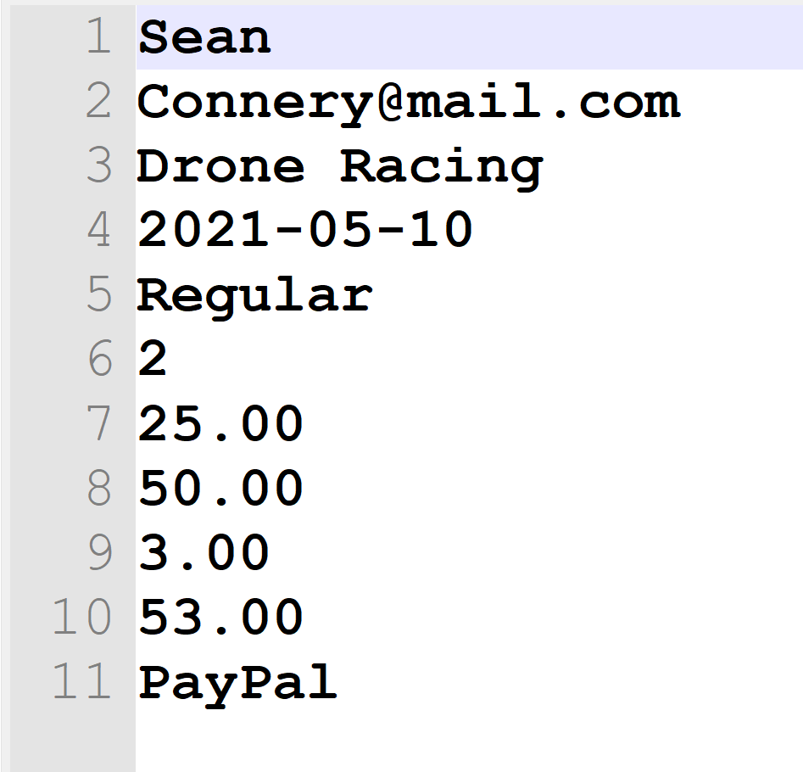

● Add text ", v4" to the end of the title (in the <head> section).

**Styles (CSS) page**

Make any style changes as needed.

**Data flow**

Here is a summary of the data flow in this web site:

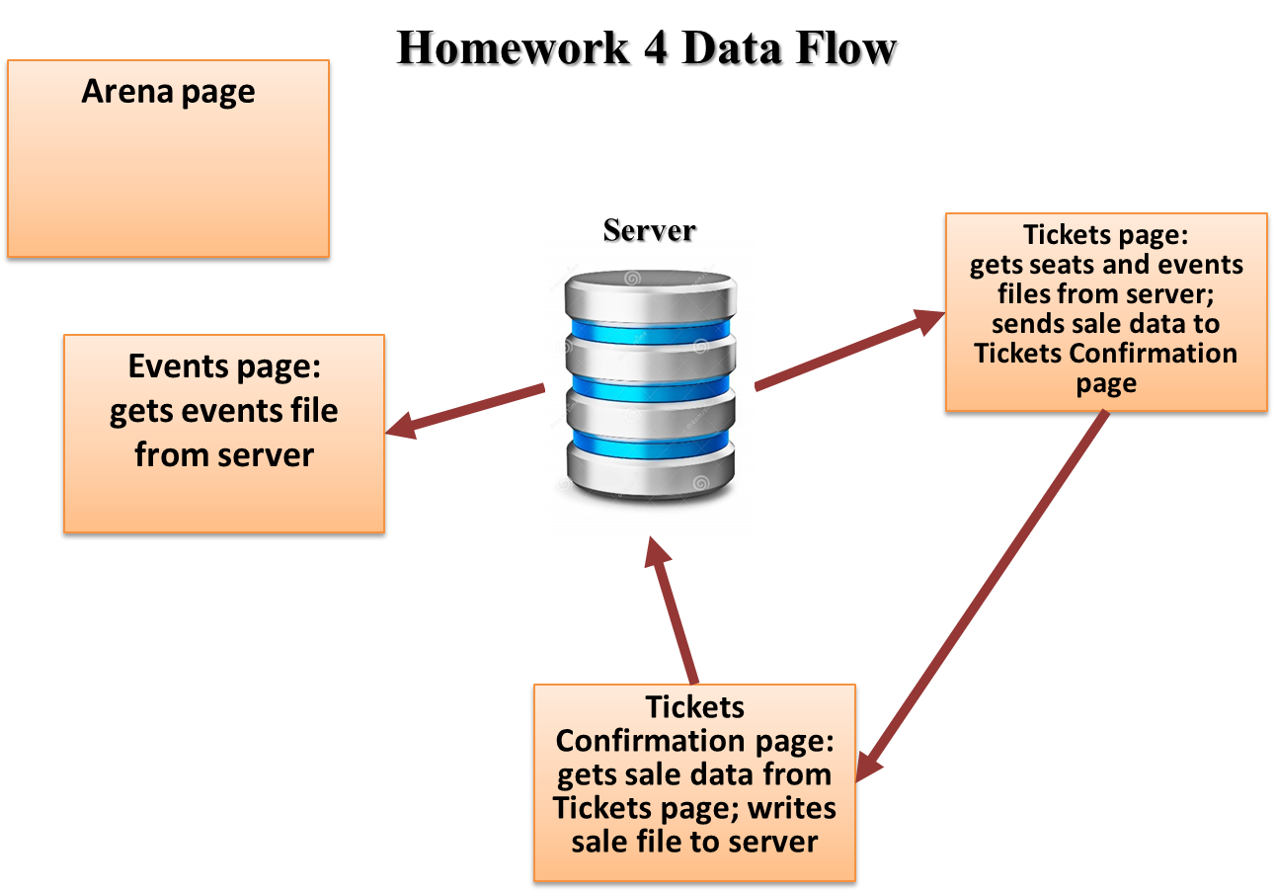

**Note:** use only relative links, not absolute links, to other files on your web site. This means there should be no drive letters or absolute paths, only relative paths, in your file references. You can test this by zipping your web site files, unzipping them in another folder, and then running your web site. There should be no linking errors if you used only relative links. The best approach is to put all web site files in one folder.

**Tickets page**

**<!DOCTYPE html>**

**<html lang="en-us">**

**<!--==================================================================**

**//**

**// Page: Crisler Arena Tickets Page**

**// Description:**

**// This web page enables a customer to order tickets for upcoming**

**// events at Crisler Arena.**

**//**

**//=================================================================-->**

**<head>**

**<title>Crisler Arena Tickets Page, v4</title>**

**<meta charset="UTF-8">**

**<meta name="author" content="Dan Ouellette"/>**

**<meta name="description" content="Crisler Arena"/>**

**<meta name="keywords" content="arena, events">**

**<!-- External CSS link -->**

**<link rel="stylesheet" type="text/css"**

**href="CrislerArena-ExternalStyles.css">**

**<!-- jQuery link -->**

**<script**

**src="https://cdnjs.cloudflare.com/ajax/libs/jquery/3.5.1/jquery.min.js">**

**</script>**

**<!-- Declare and store seats array -->**

**<script type="text/javascript">**

**"use strict";**

**// Declare arrays**

**var events;**

**var seats;**

**//================================================================**

**// loadEvents**

**//================================================================**

**function loadEvents()**

**{**

**$(function()**

**{**

**var queryString = "request=get";**

**$.getJSON(**

**"CrislerArena-Events.json",**

**queryString,**

**loadEventsResponse);**

**});**

**}**

**//================================================================**

**// loadEventsResponse**

**//================================================================**

**function loadEventsResponse(data, status)**

**{**

**events = data;**

**console.log("Events data retrieved.");**

**setEvents();**

**seatTypeSelected();**

**}**

**//================================================================**

**// loadSeats**

**//================================================================**

**function loadSeats()**

**{**

**$(function()**

**{**

**var queryString = "request=get";**

**$.getJSON(**

**"CrislerArena-Seats.json",**

**queryString,**

**loadSeatsResponse);**

**});**

**}**

**//================================================================**

**// loadSeatsResponse**

**//================================================================**

**function loadSeatsResponse(data, status)**

**{**

**seats = data;**

**console.log("Seats data retrieved.");**

**setSeats();**

**loadEvents();**

**}**

**//================================================================**

**// setSeats**

**//================================================================**

**function setSeats()**

**{**

**var html = '<input type="radio" name="cmbSeatType" id="Regular" value="Regular" checked > Regular <br>';**

**var i = 0;**

**for (i = 1; i < seats.length; i++) {**

**html += '<input type="radio" name="cmbSeatType"';**

**html += ' id="';**

**html += seats[i][0];**

**html += '" value="';**

**html += seats[i][0];**

**html += '"';**

**html += "> ";**

**html += seats[i][0];**

**html += " <br>"**

**console.log(html);**

**}**

**console.log("Seat Type radio buttons were set");**

**document.getElementById('button').innerHTML = html;**

**}**

**//================================================================**

**// setEvents**

**//================================================================**

**function setEvents()**

**{**

**// Declare variables**

**var i;**

**var op;**

**var tx;**

**// Loop through events array to build combo box**

**for (i = 0; i < events.length; i++)**

**{**

**// Create option and add to combo box**

**op = document.createElement("option");**

**op.setAttribute("value", events[i][0]);**

**tx = document.createTextNode(events[i][0]);**

**op.appendChild(tx);**

**cmbEvent.appendChild(op);**

**console.log("Option '" + events[i][0] + ", " +**

**events[i][1] + "' added.");**

**}**

**console.log("Events combo box set.");**

**}**

**//================================================================**

**// seatTypeSelected**

**//================================================================**

**function seatTypeSelected()**

**{**

**// Declare variables**

**var index;**

**if (document.getElementById('Regular').checked) {**

**index = 0;**

**//Male radio button is checked**

**} else if (document.getElementById('Mezzanine').checked) {**

**//Female radio button is checked**

**index = 1;**

**}else if (document.getElementById('Premium').checked) {**

**//Female radio button is checked**

**index = 2;**

**}**

**else if (document.getElementById('Skybox').checked) {**

**//Female radio button is checked**

**index = 3;**

**}**

**var seatCost = seats[index][1];**

**// Declare variables**

**var subtotal = txtTickets.value * seatCost;**

**var tax = subtotal * 0.06;**

**var total = subtotal + tax;**

**// Set text boxes**

**txtSeatCost.value = seatCost.toFixed(2);**

**txtSubtotal.value = subtotal.toFixed(2);**

**txtTax.value = tax.toFixed(2);**

**txtTotal.value = total.toFixed(2);**

**}**

**</script>**

**</head>**

**<body onload="loadSeats()">**

**<!-- Header section -->**

**<div class="headerPanel">**

**<h1>**

**Crisler Arena Tickets**

**</h1>**

**</div>**

**<!-- Menu section -->**

**<div class="menuPanel">**

**<h2>**

**<a href="CrislerArena-Arena.html">Arena Page</a>**

**<a href="CrislerArena-Events.html">Events Page</a>**

**<a href="CrislerArena-Tickets.html">Tickets Page</a>**

**</h2>**

**</div>**

**<hr>**

**<!-- Left panel -->**

**<div class="contentPanel3">**

**<!-- Form -->**

**<form action="TicketsConfirmation.php" method="get">**

**<!-- Customer name and e-mail -->**

**<label>Customer name:</label>**

**<input type="text" name="txtCustomerName" required>**

**<br><br>**

**<label>Customer e-mail:</label>**

**<input type="email" name="txtCustomerEmail" required>**

**<br><br>**

**<!-- Event name and date -->**

**<label>Event:</label>**

**<select id="cmbEvent" name="cmbEvent">**

**</select>**

**<br><br>**

**<label>Date:</label>**

**<input type="date" name="txtDate" value="2021-05-10" required>**

**<br><br>**

**<!-- Seat type and ticket count -->**

**<fieldset>**

**<legend name="cmbSeatType" id="cmbSeatType">Seat Type: </legend>**

**<div id="button" onchange="seatTypeSelected()">**

**</div>**

**</fieldset>**

**<br><br>**

**<!-- Ticket count -->**

**<label>Tickets (1-21):</label>**

**<input**

**type="number" name="txtTickets" id="txtTickets" value="2"**

**min="1" step="1" max="21" required**

**onchange="seatTypeSelected()"**

**>**

**<br><br>**

**<!-- Costs -->**

**<label>Seat cost ($):</label>**

**<input type="text" name="txtSeatCost" id="txtSeatCost" readonly>**

**<br><br>**

**<label>Subtotal ($):</label>**

**<input type="text" name="txtSubtotal" id="txtSubtotal" readonly>**

**<br><br>**

**<label>Tax ($):</label>**

**<input type="text" name="txtTax" id="txtTax" readonly>**

**<br><br>**

**<label>Total ($):</label>**

**<input type="text" name="txtTotal" id="txtTotal" readonly>**

**<br><br>**

**<!-- Payment type fieldset -->**

**<fieldset>**

**<legend>Payment type</legend>**

**<input type="radio" name="rbTimeSlot" value="Credit" checked> Credit<br>**

**<input type="radio" name="rbTimeSlot" value="PayPal"> PayPal<br>**

**<input type="radio" name="rbTimeSlot" value="Venmo"> Venmo<br>**

**</fieldset>**

**<br><br>**

**<!-- Form buttons -->**

**<input type="submit">**

**<input type="reset" value="Reset" class="formButton">**

**</form>**

**</div>**

**<!-- Right panel -->**

**<div class="contentPanel3">**

**<!-- Arena seating chart -->**

**<img**

**src="CrislerArenaSeatingChart.png" alt="Image Missing!"**

**width="70%" height="70%"**

**/>**

**</div>**

**<!-- Footer section -->**

**<div class="footerPanel">**

**<h3>**

**Crisler Arena**

**&nbsp;&nbsp;333 East Stadium Blvd, Ann Arbor, MI 48109, MI**

**&nbsp;&nbsp;734-761-3355**

**&nbsp;&nbsp;<a href="mailto:info@crislerarena-annarbor.com">Email Us!</a>**

**&nbsp;&nbsp;Copyright &#169; 2021**

**</h3>**

**</div>**

**</body>**

**</html>**

**Tickets Confirmation page**

**<!DOCTYPE html>**

**<html lang="en-us">**

**<!--==================================================================**

**//**

**// Page: Crisler Arena Tickets Page**

**// Description:**

**// This web page enables a customer to order tickets for upcoming**

**// events at Crisler Arena.**

**//**

**//=================================================================-->**

**<head>**

**<title>Ticket Confirmation Page, v4</title>**

**<meta charset="UTF-8">**

**<meta name="author" content="Dan Ouellette"/>**

**<meta name="description" content="Crisler Arena"/>**

**<meta name="keywords" content="arena, events">**

**<!-- External CSS link -->**

**<link rel="stylesheet" type="text/css"**

**href="CrislerArena-ExternalStyles.css">**

**<!-- jQuery link -->**

**<script**

**src="https://cdnjs.cloudflare.com/ajax/libs/jquery/3.5.1/jquery.min.js">**

**</script>**

**</head>**

**<body>**

**<!-- Header section -->**

**<div class="headerPanel">**

**<h1>**

**Ticket Confirmation Page**

**</h1>**

**</div>**

**<!-- Menu section -->**

**<div class="menuPanel">**

**<h2>**

**<a href="CrislerArena-Arena.html">Arena Page</a>**

**<a href="CrislerArena-Events.html">Events Page</a>**

**<a href="CrislerArena-Tickets.html">Tickets Page</a>**

**</h2>**

**</div>**

**<hr>**

**See you soon at our arena! Here are your ticket details:**

**<br><br>**

**Customer name: <?php echo $_GET["txtCustomerName"]; ?><br>**

**Customer e-mail: <?php echo $_GET["txtCustomerEmail"]; ?><br>**

**Event: <?php echo $_GET["cmbEvent"]; ?><br>**

**Date: <?php echo $_GET["txtDate"]; ?><br>**

**Seat type: <?php echo $_GET["cmbSeatType"]; ?><br>**

**Ticket count: <?php echo $_GET["txtTickets"]; ?><br>**

**Seat cost ($): <?php echo $_GET["txtSeatCost"]; ?><br>**

**Subtotal ($): <?php echo $_GET["txtSubtotal"]; ?><br>**

**Tax ($): <?php echo $_GET["txtTax"]; ?><br>**

**Total ($): <?php echo $_GET["txtTotal"]; ?><br>**

**Payment type: <?php echo $_GET["rbTimeSlot"]; ?><br>**

**<br>**

**Administrative Use Only <br>**

**<?php**

**$name = $_GET["txtCustomerName"];**

**$file_name = $name . '.sale';**

**// Open the text file**

**$f = fopen($file_name, "w");**

**?>**

**File <?php echo $file_name ?> written to server. <br>**

**<?php fwrite($f, $_GET["txtCustomerName"] . PHP_EOL );**

**fwrite($f, $_GET["txtCustomerEmail"] . PHP_EOL);**

**fwrite($f, $_GET["cmbEvent"] . PHP_EOL);**

**fwrite($f, $_GET["txtDate"]. PHP_EOL);**

**fwrite($f, $_GET["cmbSeatType"] . PHP_EOL);**

**fwrite($f, $_GET["txtTickets"] . PHP_EOL);**

**fwrite($f, $_GET["txtSeatCost"] . PHP_EOL);**

**fwrite($f, $_GET["txtSubtotal"] . PHP_EOL);**

**fwrite($f, $_GET["txtTax"] . PHP_EOL);**

**fwrite($f, $_GET["txtTotal"] . PHP_EOL);**

**fwrite($f, $_GET["rbTimeSlot"]);**

**// Close the text file**

**fclose($f);**

**// Open file for reading, and read the line**

**$f = fopen($file_name, "r");**

**fclose($f);**

**?>**

**<!-- Footer section -->**

**<div class="footerPanel">**

**<h3>**

**Crisler Arena**

**&nbsp;&nbsp;333 East Stadium Blvd, Ann Arbor, MI 48109, MI**

**&nbsp;&nbsp;734-761-3355**

**&nbsp;&nbsp;<a href="mailto:info@crislerarena-annarbor.com">Email Us!</a>**

**&nbsp;&nbsp;Copyright &#169; 2021**

**</h3>**

**</div>**

**</body>**

**</html>**

**Sequence 1**

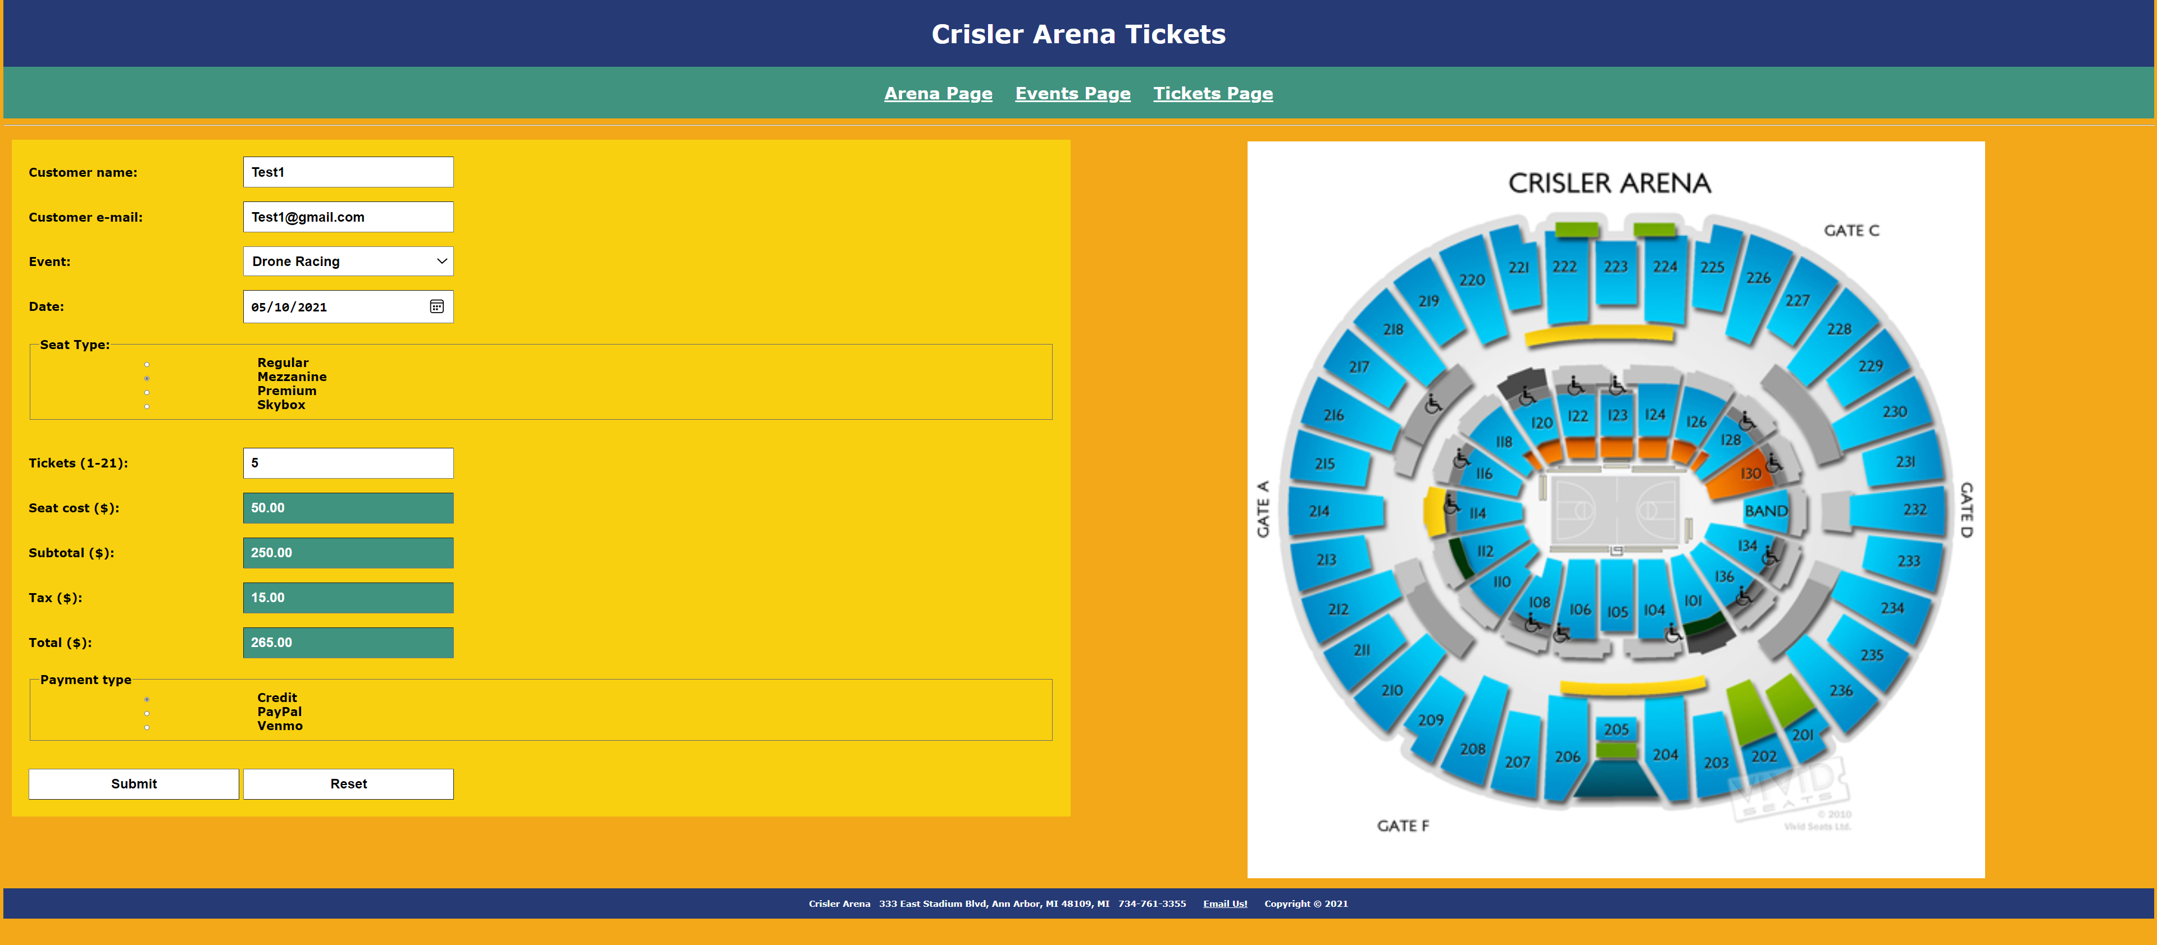

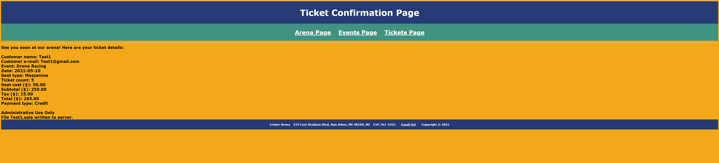

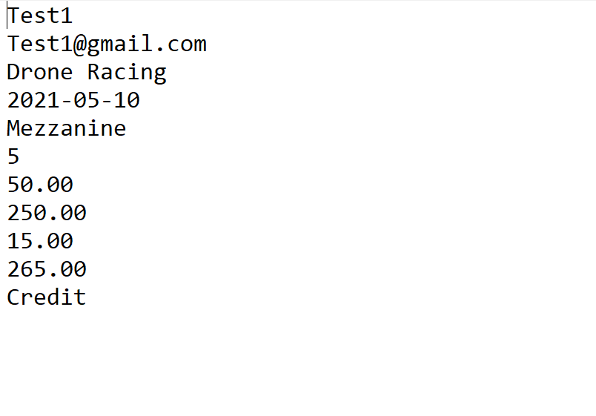

**Sequence 2**

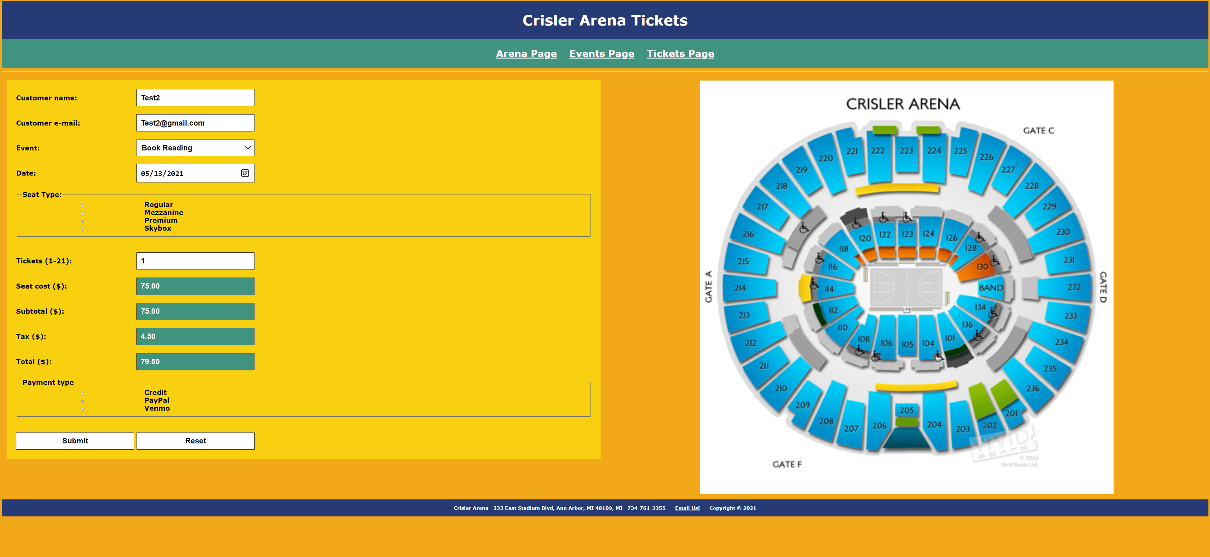

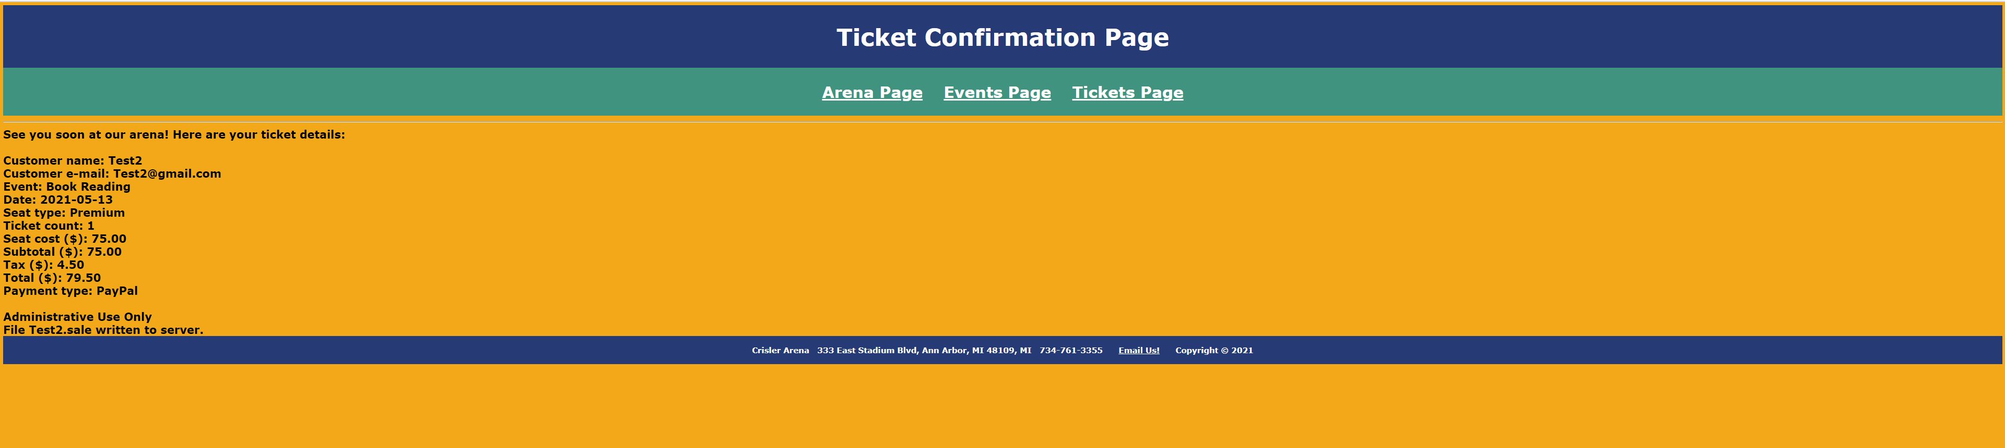

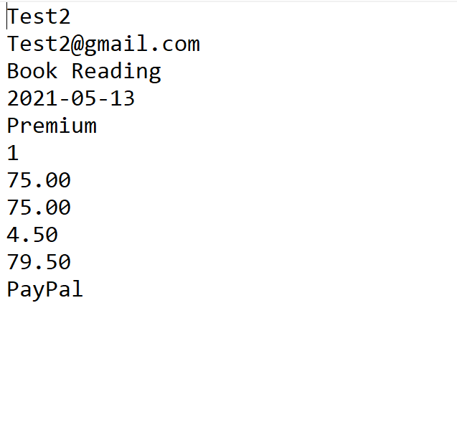

**Sequence 3**

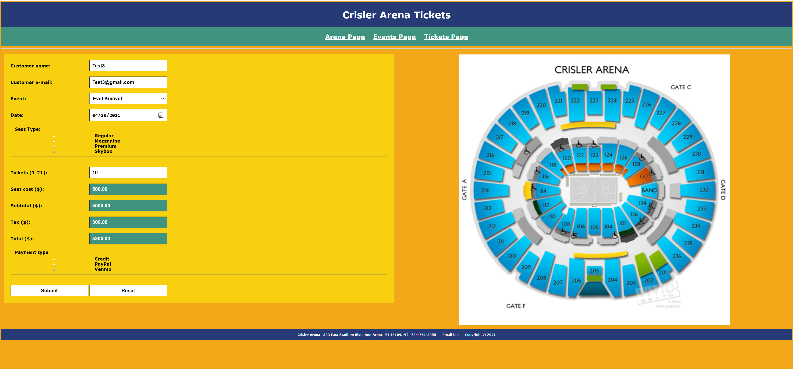

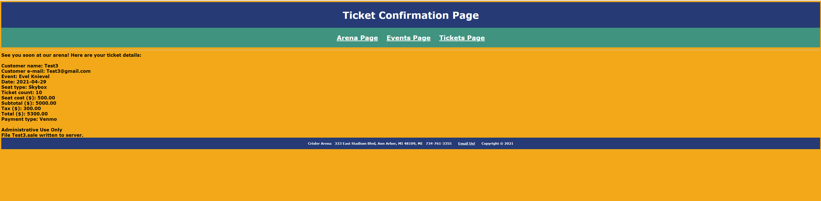

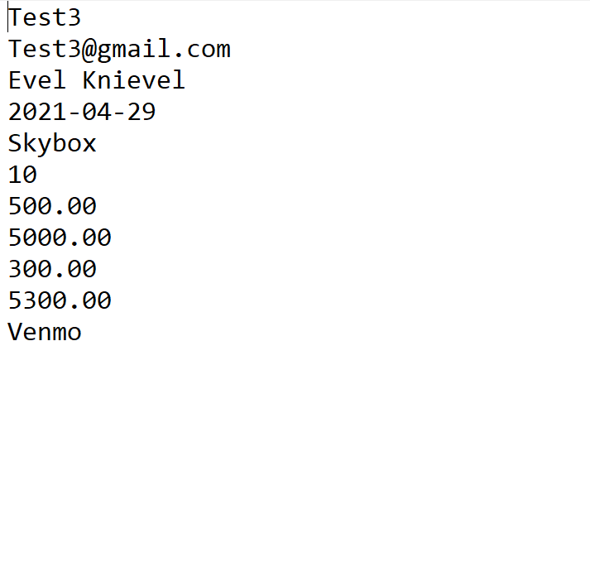

**CSS file**

**/*====================================================================**

**Title: Crisler Arena - External Styles**

**Description:**

**This CSS page contains external styles for the web site. The color**

**scheme used is composed of five colors:**

**#F2A819 - dark gold like**

**#F8D010 - light gold like**

**#263B75 - blue like**

**#40937F - teal like**

**#E85134 - orange like**

**====================================================================*/**

**/*====================================================================**

**General style**

**====================================================================*/**

**\***

**{**

**box-sizing: border-box;**

**}**

**/*====================================================================**

**Body style**

**====================================================================*/**

**body**

**{**

**background-color:#F2A819;**

**font-family:verdana, georgia, san-serif;**

**font-size:28px;**

**font-weight:bold;**

**}**

**/*====================================================================**

**Anchor style**

**====================================================================*/**

**a**

**{**

**color:white;**

**padding:20px;**

**}**

**/*====================================================================**

**Form style**

**====================================================================*/**

**form**

**{**

**background-color:#F8D010;**

**color:black;**

**padding:40px;**

**}**

**/*====================================================================**

**Heading styles**

**====================================================================*/**

**h1**

**{**

**font-size:60px;**

**text-align:center;**

**}**

**h2**

**{**

**font-size:40px;**

**text-align:center;**

**}**

**h3**

**{**

**font-size:20px;**

**text-align:center;**

**}**

**/*====================================================================**

**Image style**

**====================================================================*/**

**img**

**{**

**display:block;**

**margin-left:auto;**

**margin-right:auto;**

**padding:4px;**

**}**

**/*====================================================================**

**Input and select styles**

**====================================================================*/**

**input, select**

**{**

**background-color:white;**

**font-size:32px;**

**font-weight:bold;**

**padding:16px;**

**width:500px;**

**}**

**input[readonly]**

**{**

**background-color:#40937F;**

**color:white;**

**font-size:32px;**

**font-weight:bold;**

**padding:16px;**

**width:500px;**

**}**

**/*====================================================================**

**Label style**

**====================================================================*/**

**label**

**{**

**display:inline-block;**

**font-size:28px;**

**width:500px;**

**}**

**/*====================================================================**

**Class styles**

**====================================================================*/**

**.headerPanel**

**{**

**background-color:#263B75;**

**clear:both;**

**color:white;**

**padding:4px;**

**width:100%;**

**}**

**.menuPanel**

**{**

**background-color:#40937F;**

**clear:both;**

**padding:4px;**

**width:100%;**

**}**

**.contentPanel1**

**{**

**color:black;**

**float:left;**

**padding:20px;**

**width:40%;**

**}**

**.contentPanel2**

**{**

**background-color:#F8D010;**

**color:black;**

**float:left;**

**padding:20px;**

**width:20%;**

**}**

**.contentPanel3**

**{**

**float:left;**

**padding:20px;**

**width:50%;**

**}**

**.tablePanel**

**{**

**background-color:#F8D010;**

**clear:both;**

**padding:4px;**

**width:100%;**

**}**

**.footerPanel**

**{**

**background-color:#263B75;**

**clear:both;**

**color:white;**

**padding:4px;**

**width:100%;**

**}**

**/*====================================================================**

**Pseudo classes**

**====================================================================*/**

**a:hover**

**{**

**background-color:#E85134;**

**color:white;**

**}**

**.formButton:hover**

**{**

**background-color:#E85134;**

**color:white;**

**}**

**If possible, format your code like this:**

**Font “Courier New”**

**Font size “9”**

**Bold**

**\* Copying-and-pasting web page code to a Word document**

**macOS**

1) From within the HTML editor window, press **command-A** and press **command-C**.

2) From within the Word document, press **command-V**.

**Windows**

1) From within the HTML editor window, press **CTRL-A** and press **CTRL-C**.

2) From within the Word document, press **CTRL-V**.

**\*\* Copying-and-pasting a web page to a Word document**

**macOS**

1) From the browser window, press **shift-command-4-space**.

2) From within the Word document, **command-V**.

**Windows**

1) From the browser window, press **ALT-PrintScreen**.

2) From within the Word document, press **CTRL-V**.